Installing Software Needed for Backend

***make sure you are in git/rabbtmqphp_example***

1. 

This will install mysql onto the VM

1. 
   1. Installs PHP connect to MySQL (MySQLi extension & PDO - PHP Data Objects)

Gaining access to mysqlconnect.php file

* Use ‘git checkout sample’
* Use ‘git checkout mysql_example’

If these don’t work, try ‘sudo’ before ‘git checkout’

* Type ‘ls’ to confirm mysqlconnect.php is in the repo

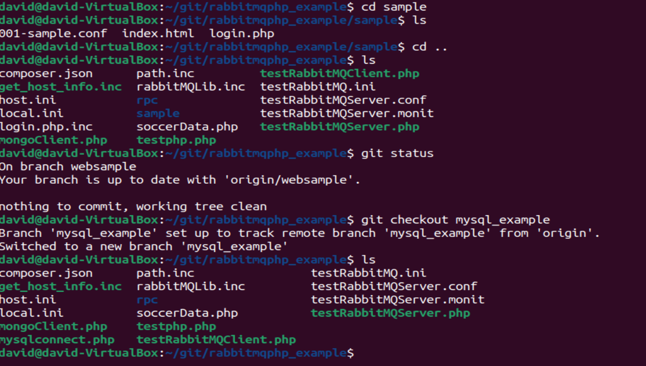

Creating the Database

1. 
   1. Here you want to change the credentials of of username and password within this file. What to change is on Step 4.
2. 
   1. Specifying test user for database, ‘test_user’ and ‘password’, (can be anything for actual database later but this is just to get it working) ‘127.0.0.1’ and ‘testdb’ can remain unchanged
3. 
   1. This is where you will be creating the database and its contents.
4. 
   1. Created test_user with password ‘password’ for accessing database
   2.  exit out of mysqli
5. 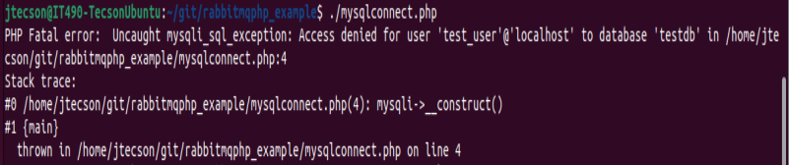
   1. Check to ensure that this is the error that you get when running mysqlconnect.php
6. go back into the mysqli command line
7. 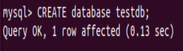 create database + name testdb
8. grant privileges to access db
   1.  exit out of mysqli
9. 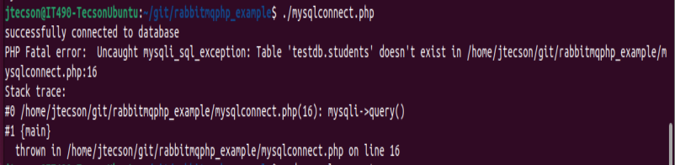

Second expected error when running mysqlconnect.php, should display “successfully connected to database”, now we have to create students table to populate database

1.  go back into mysqli
2. 

specify that we are going to use testdb so we can add a table to it, should display “Database changed” once Use testdb; is entered

1. 

Added students table to testdb

1. 

Test if you can enter in a student using Insert into students…

1. 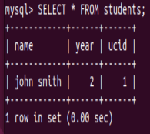

“SELECT * FROM students;” to see if table shows up

1. If all good, 
2. 

Run mysqlconnect.php one last time and it should just only display “successfully connected to database”

=========================================================

FOR REPEATED ACCESS OF DATABASE: see below

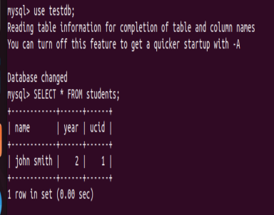

Make sure to ‘use testdb;’ (testdb can be whatever name we give for our actual database)

And then input whatever command such as ‘SELECT * FROM students;’